RESEARCH GRANT AGREEMENT

BETWEEN

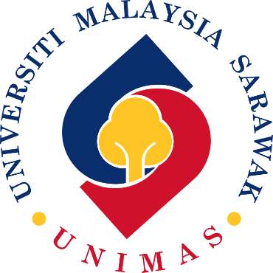
UNIVERSITI MALAYSIA SARAWAK

and

FOR THE RESEARCH COLLABORATION ENTITLED

