TITLE

Researchers: Names of researchers
Faculty/Institute/Centre:

(Brief descriptions of Invention)

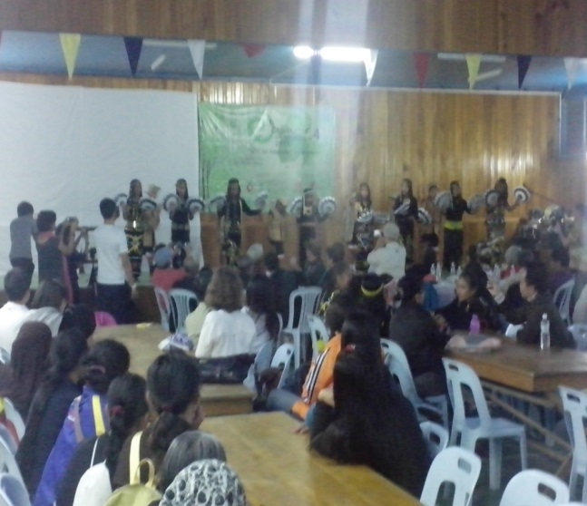
Picture of Invention
Caption

